(CHECK )- Employee Student Vendor

Contact Information
Name: ____________________________________________
Vendor Tax ID #: ____________________________________________
(Outside Vendors ONLY)
Address: ____________________________________________
City, State & Zip: ____________________________________________
Email (REQUIRED): ____________________________________________
Telephone: ____________________________________________

TCNJ Employees/Students with Payroll Direct Deposit- Employee ID#: Student ID#:
By checking the box, I hereby authorize Finance & Business Services to obtain my banking information from TCNJ’s Payroll Department.

If you have more than one Payroll direct deposit account, please specify the account to be used for Accounts Payable reimbursements.

Account No. Account Type: Checking Savings

Signature: ____________________________________________ Date: _________________________

If you do not have Payroll direct deposit or want to use a different account, please complete this section.
Bank Information
Routing/Transit Number: (9 digits)
Bank Name:
Account Number:
Account Type: Checking Savings
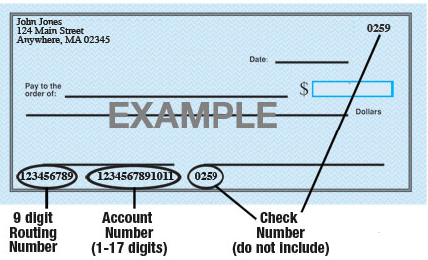
*Authorization: I hereby authorize The College of New Jersey to deposit funds directly into the account designated. I understand that all subsequent payments to me will be via direct deposit. I agree that The College of New Jersey will not be responsible for any incorrect information I provide.
x______________________________________________ ____________________________
Signature Date

